**Git Programs**

**1. Do the following using Git.**

* 1. **Also create a new directory**
  2. **init command for repository,**
  3. **Create a README file**
  4. **Creation of commit file using GIT**
  5. **use the log command in order to see all of the commits you made so far.**
  6. **use the show command to look at an individual commit.**

**Aim:**

To implement version control in git

**Steps:**

1. Open git bash shell
2. mkdir labprograms
3. cd labprograms
4. ls –la
5. git init
6. cat .git/config
7. git config --local user.name "IIBCASII"
8. cat .git/config
9. vim README.txt
10. git status
11. git add README.txt
12. git status
13. git commit –m “first commit”
14. git status
15. git branch
16. git log
17. vim README.txt 🡪 do the changes
18. git diff README.txt
19. git log
20. git show commitid
21. vim README.txt 🡪 do the changes
22. git add README.txt
23. git commit –m “second commit”
24. git log

**Output**

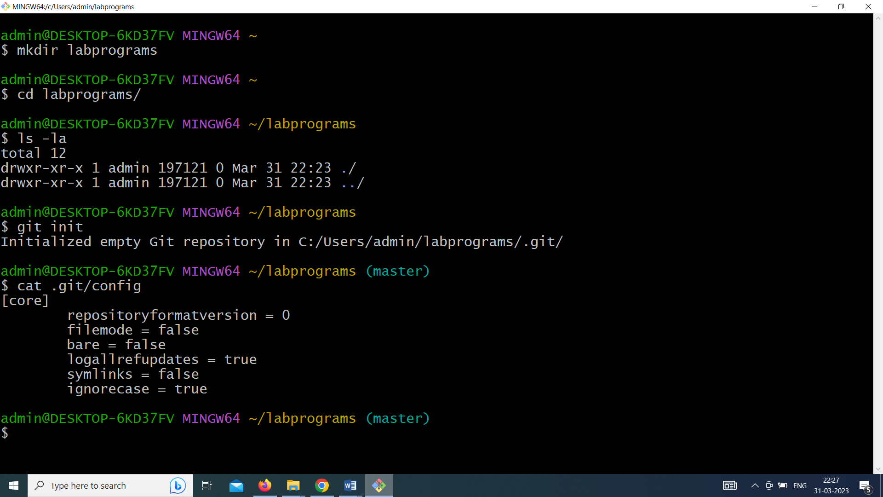

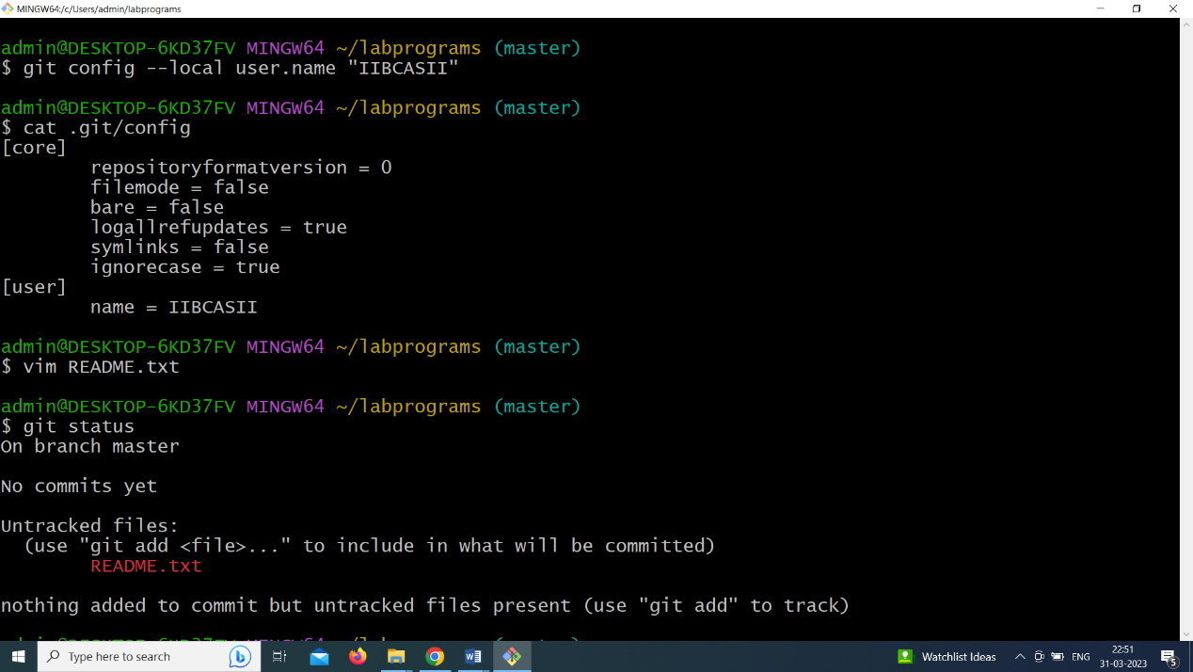

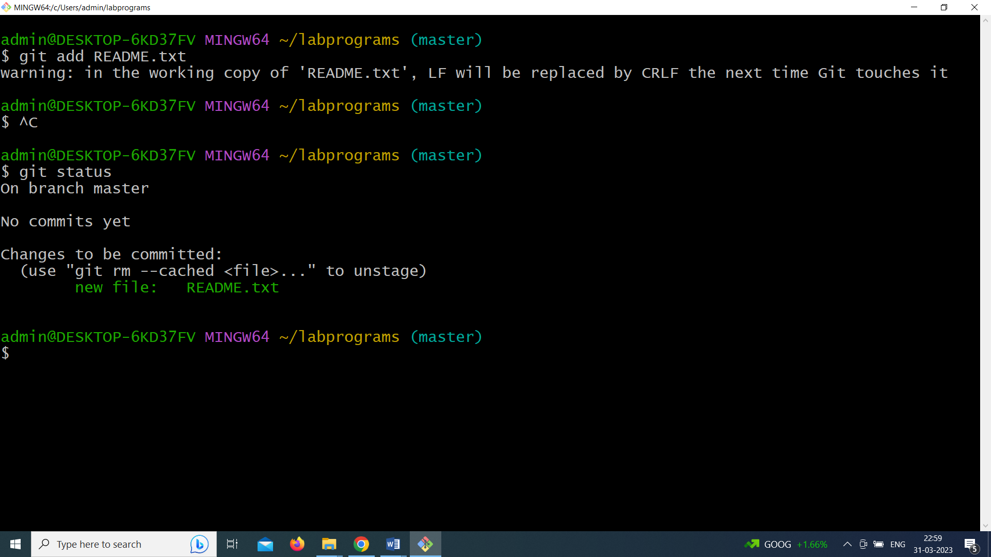

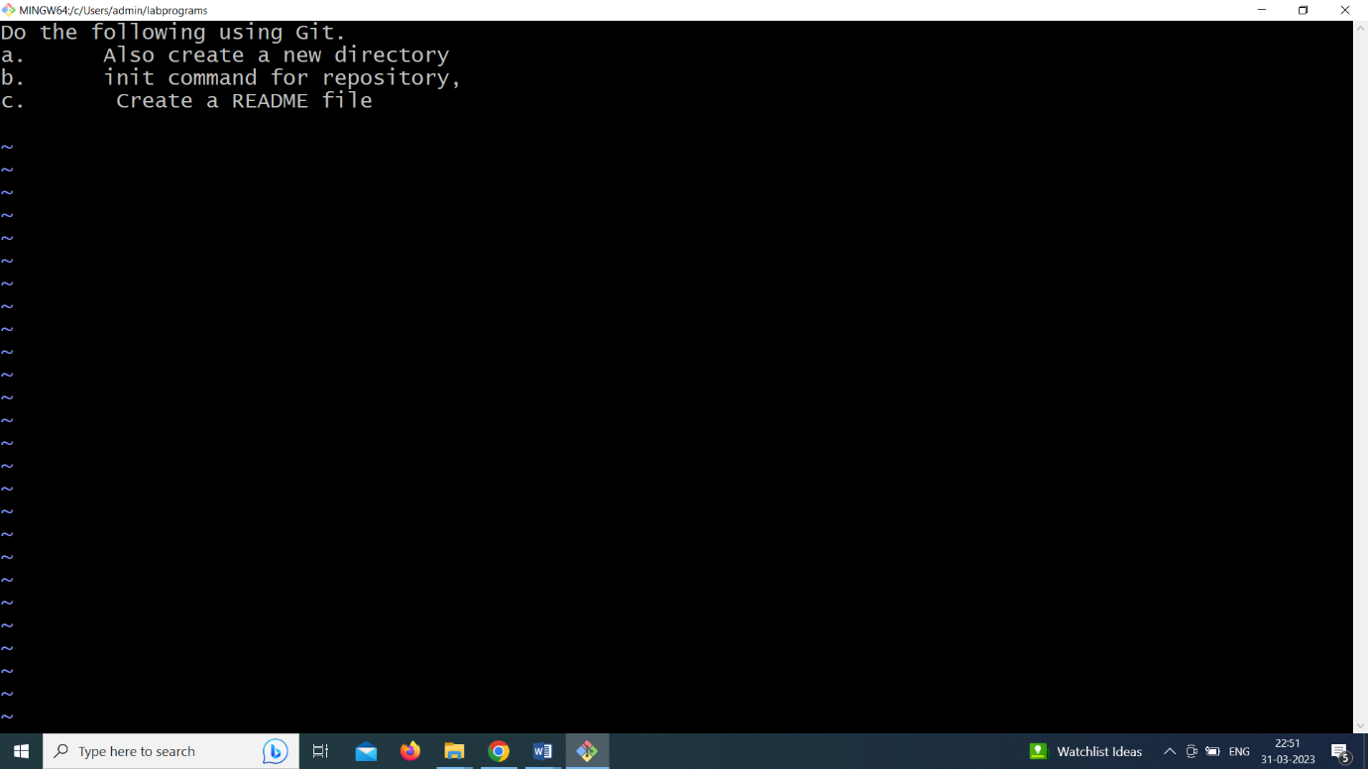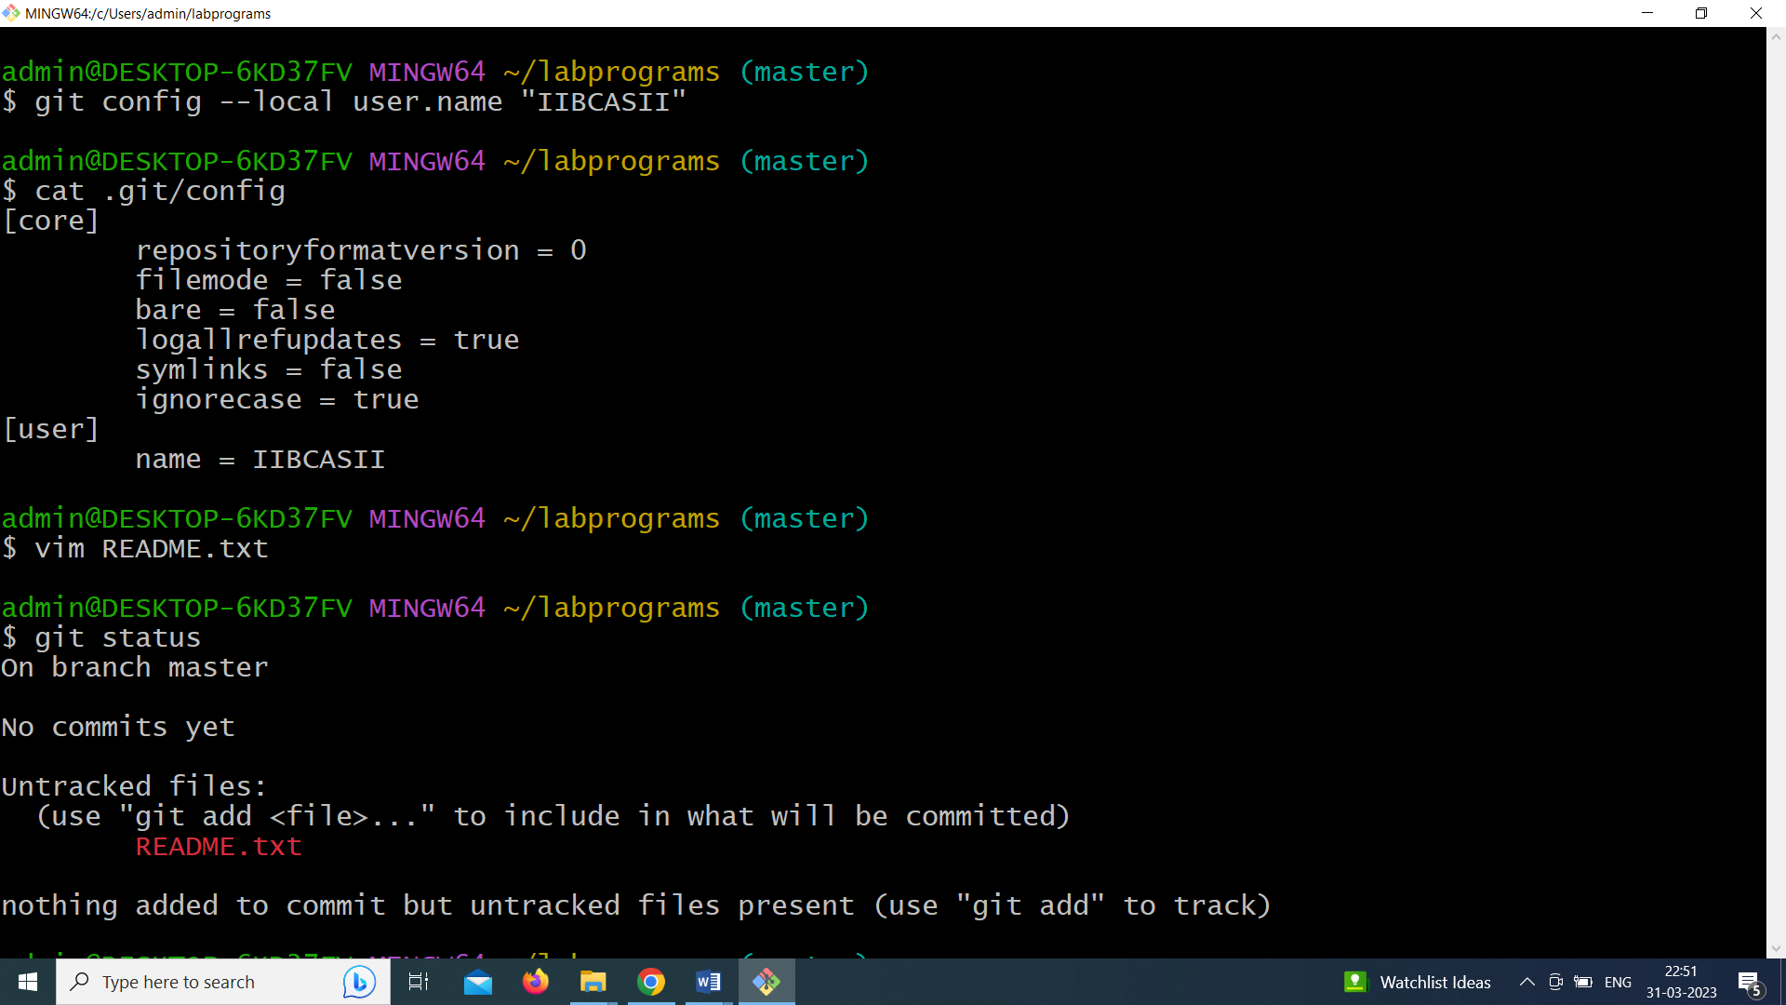

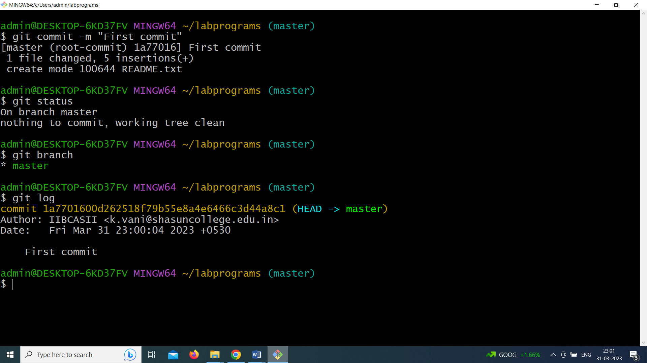

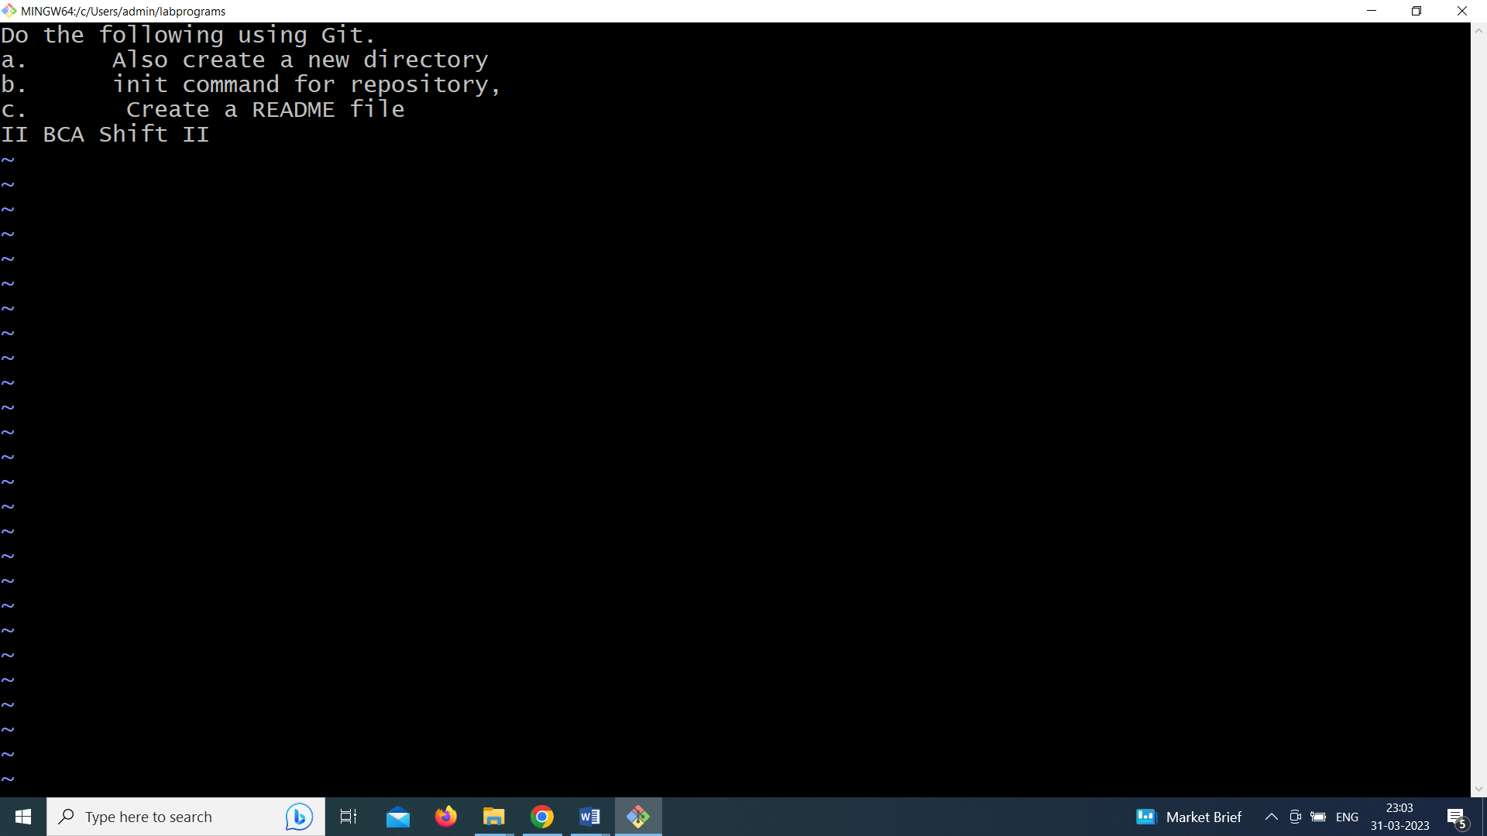

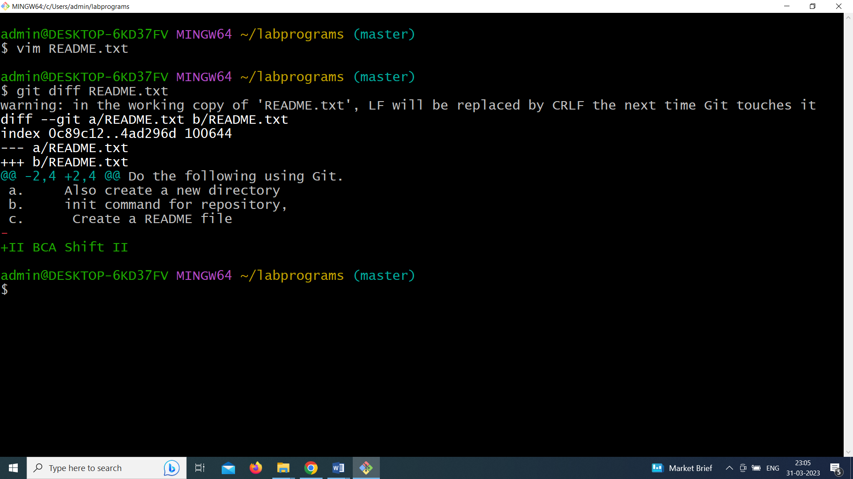

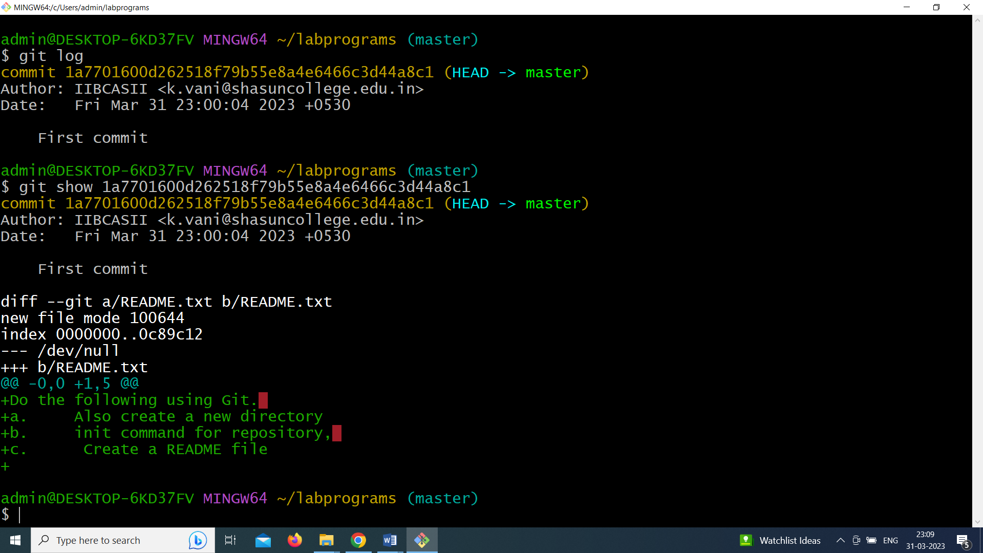

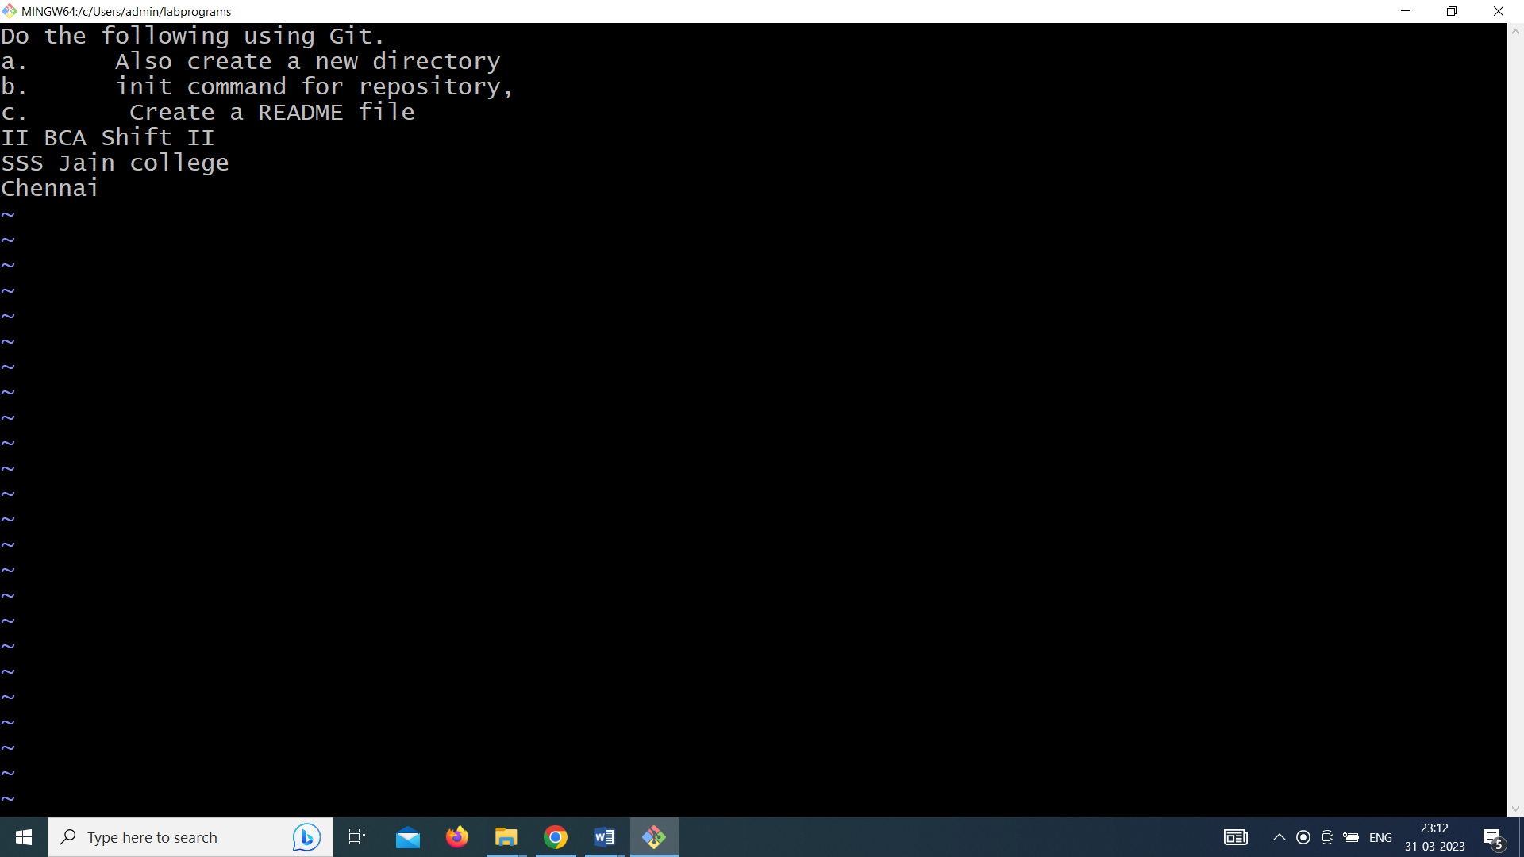

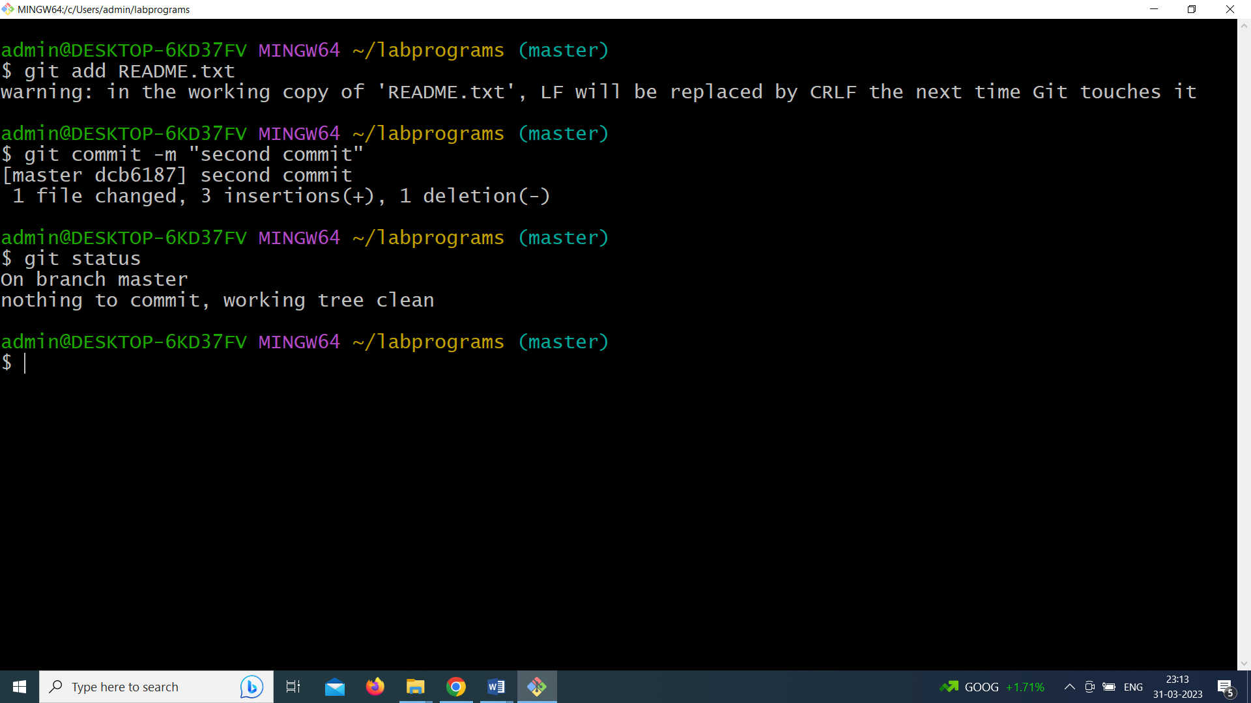

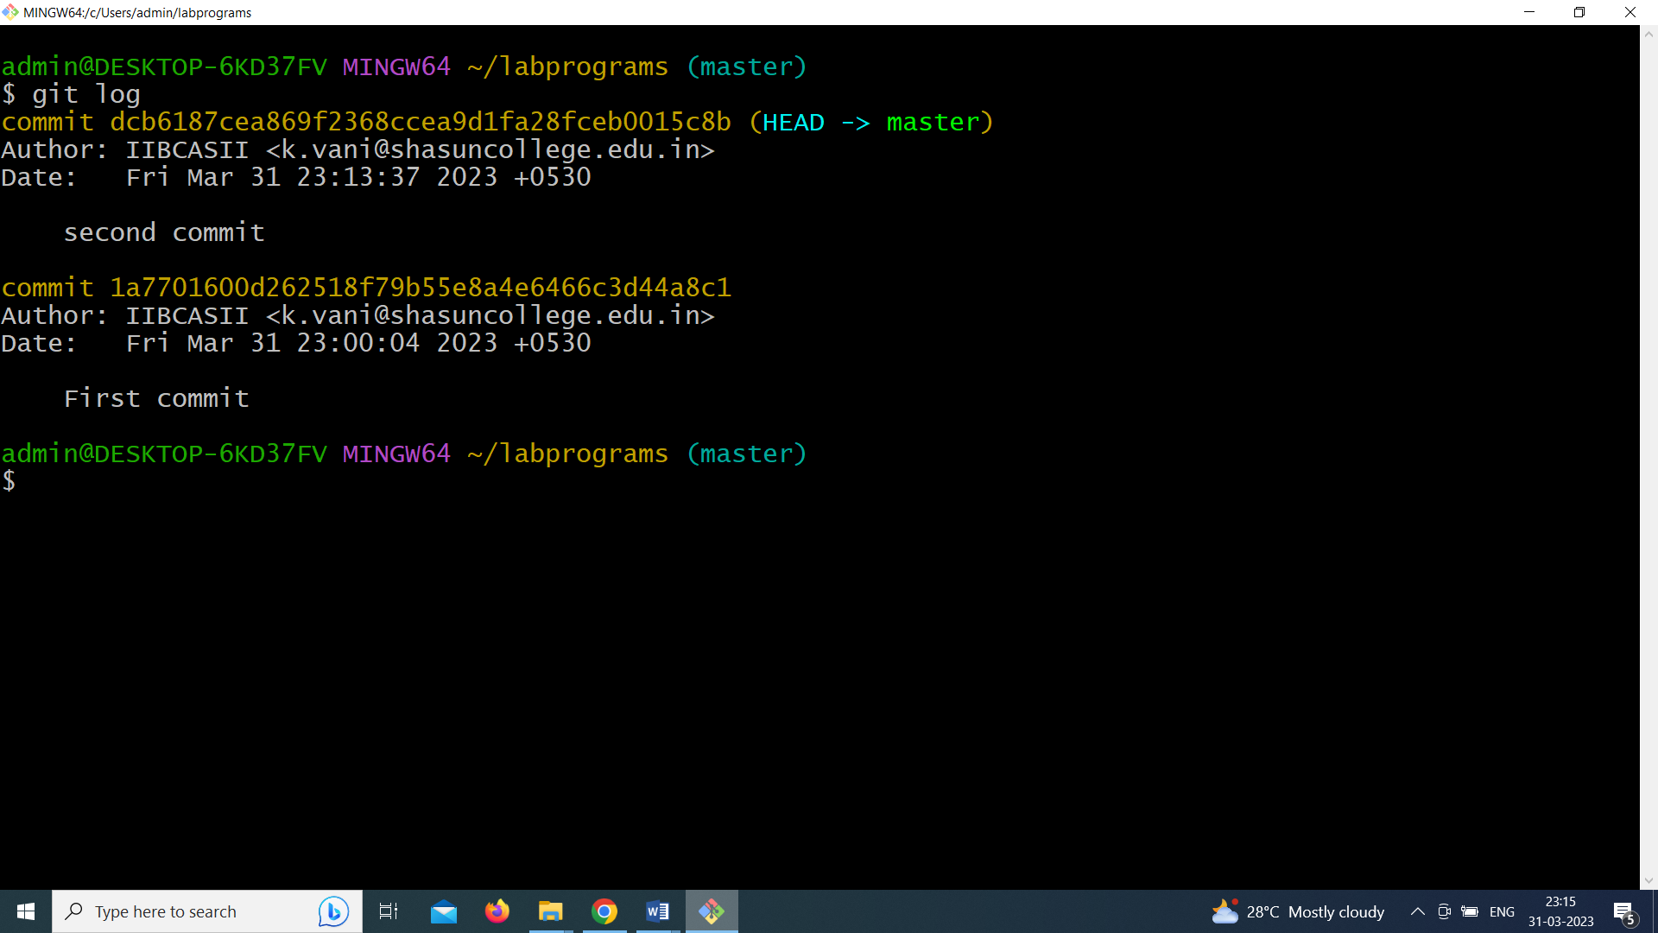

1. **In GIT use the commit command to commit the contents of the staging area. Create a src directory and add a couple of files to it.**

**Aim:**

To implement version control in git by creating src directory and add the few files

**Steps:**

1. Open git bash shell
2. mkdir src
3. cd src
4. ls –la
5. git init
6. cat .git/config
7. git config --local user.name "IIBCASIISRC"
8. vim file1.html 🡪 type the content &save the file
9. vim file2.html🡪 type the content &save the file
10. vim file3.html 🡪type the content &save the file
11. git add .
12. git commit –m “first creation”
13. vim file1.html🡪 do some changes
14. git add file1.html
15. git commit –m “file1 changes”
16. git log

**Output**

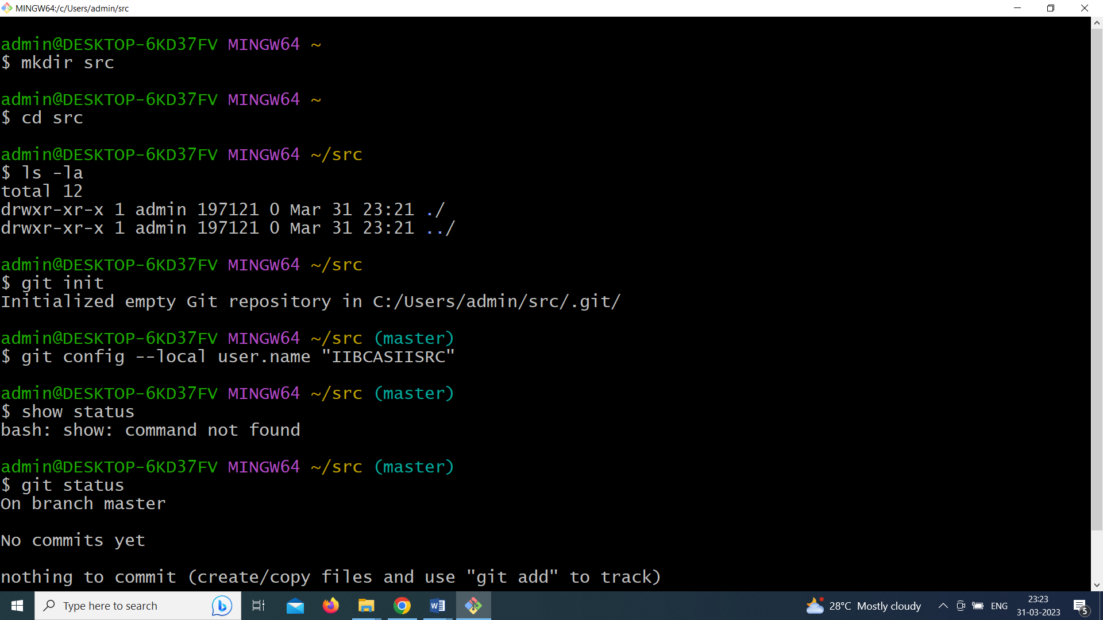

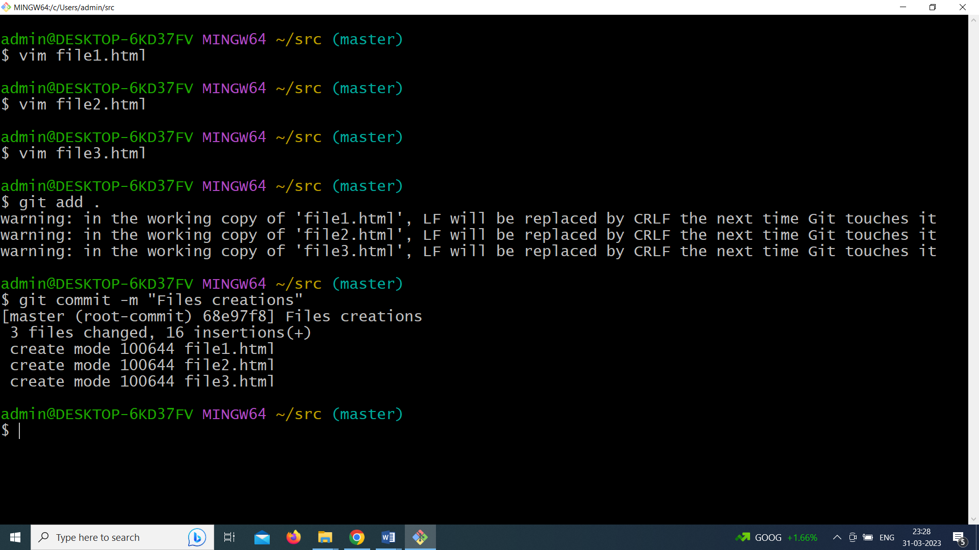

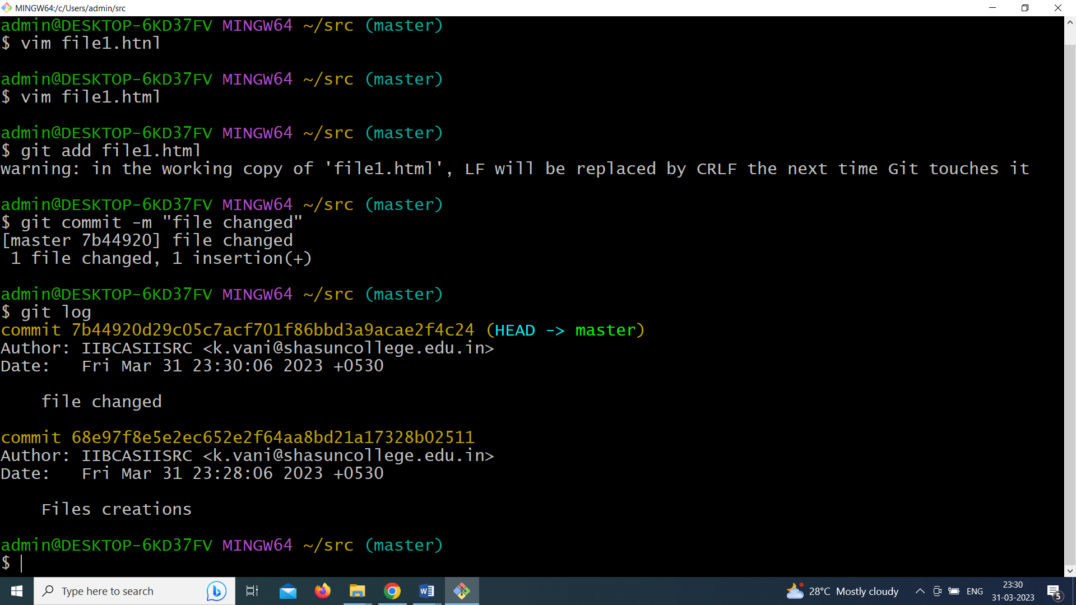

1. **Create a repo on GitHub that contains a markdown file with question and answer.**

**Aim:**

To create a repo on GitHub that contains a markdown file with question and answer**.**

**Steps:**

1. Open 🡪https://github.com/
2. Select signup and create the id
3. Then sign in in to the github using that id and password
4. Select repository
5. Select new
6. Give the repository name
7. Select create repository
8. Creates a file with question and answer.
9. Select commit new file

**Output**

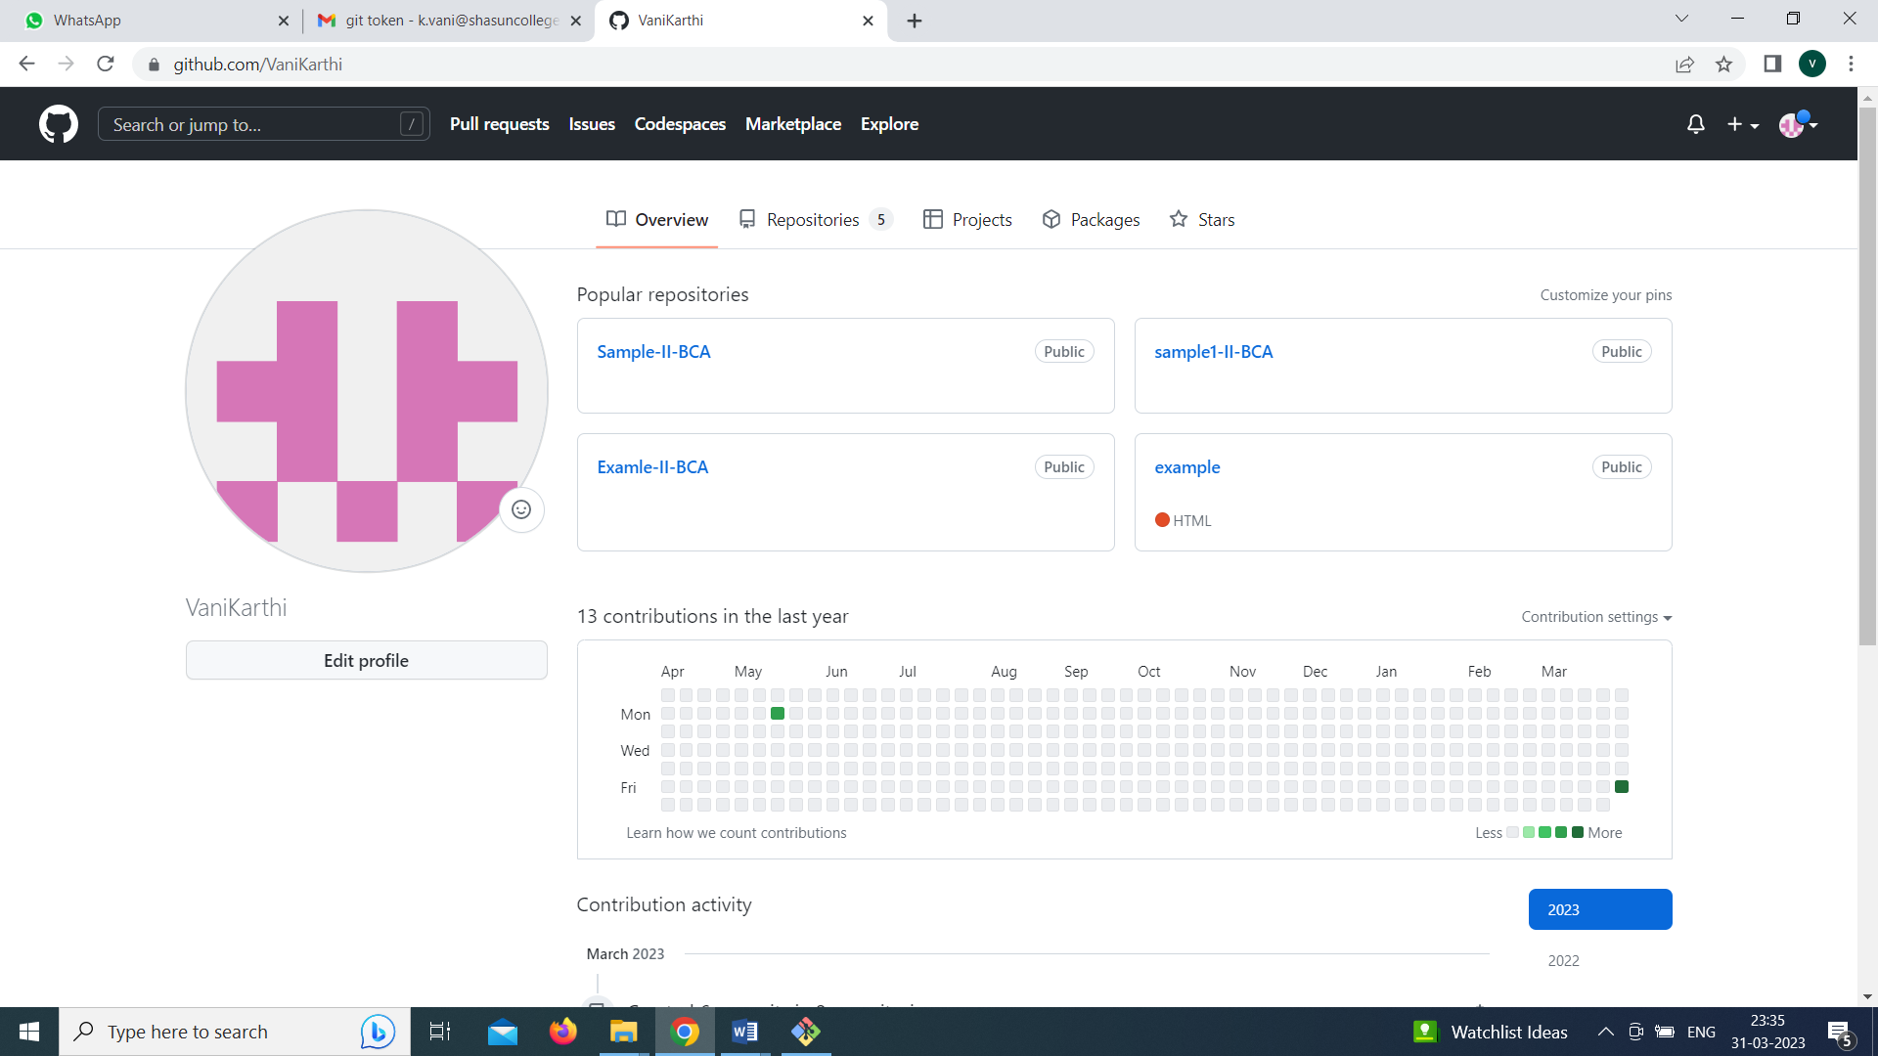

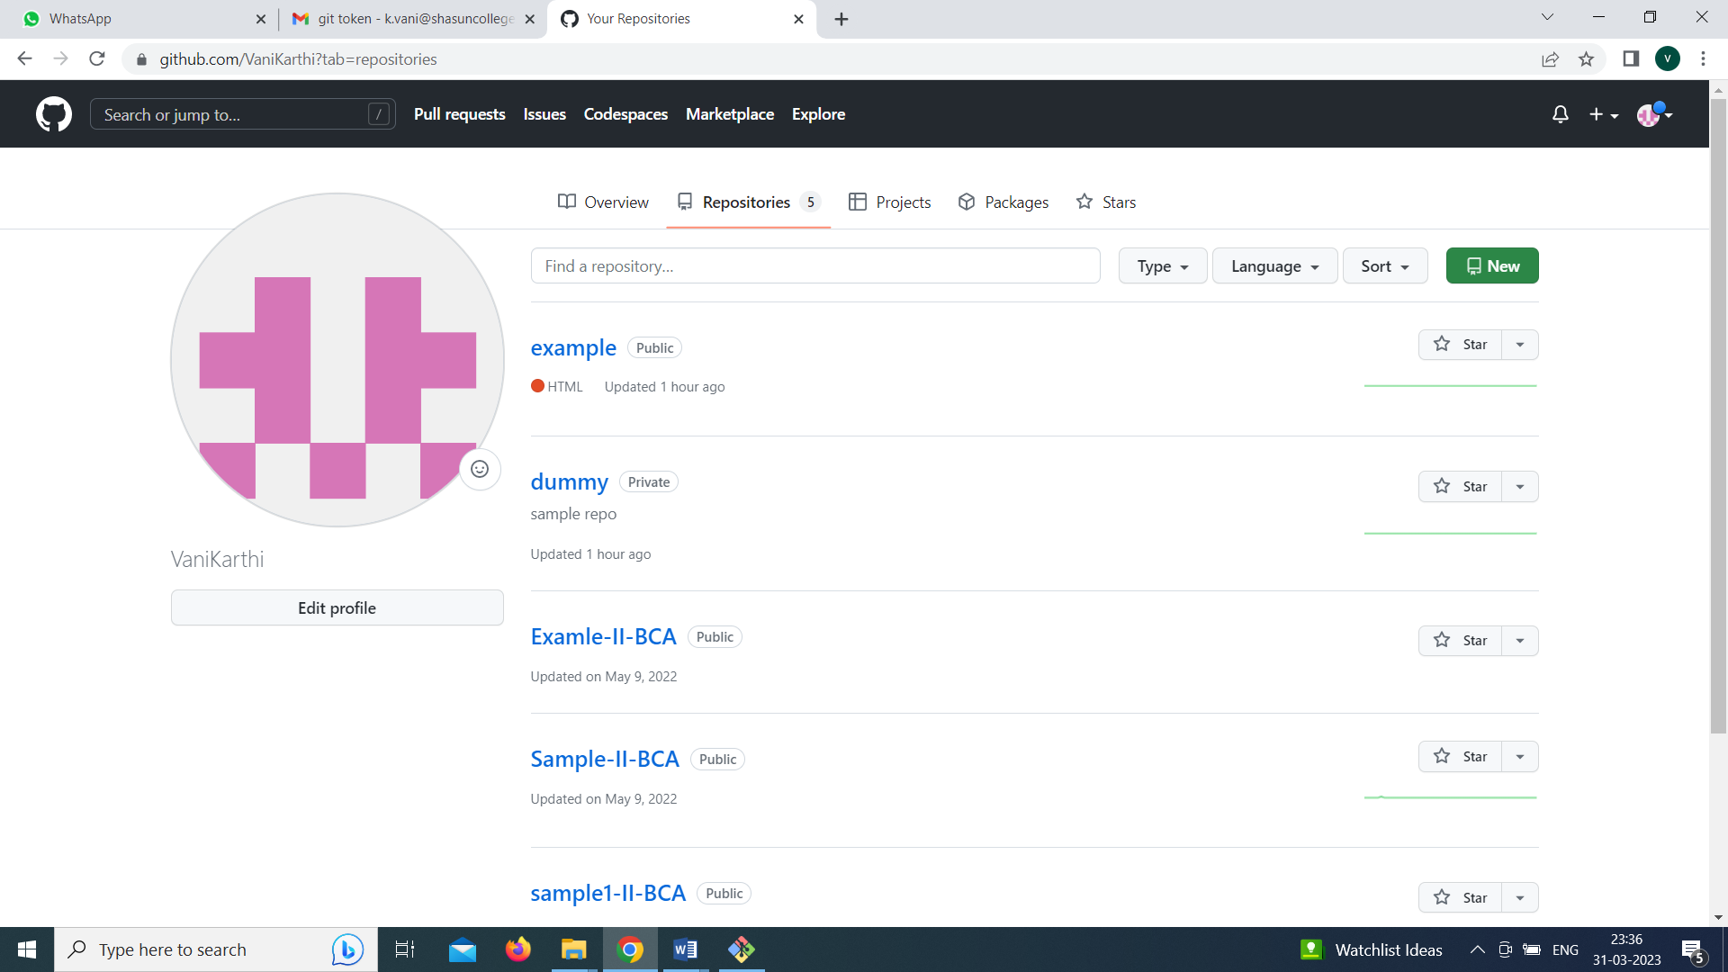



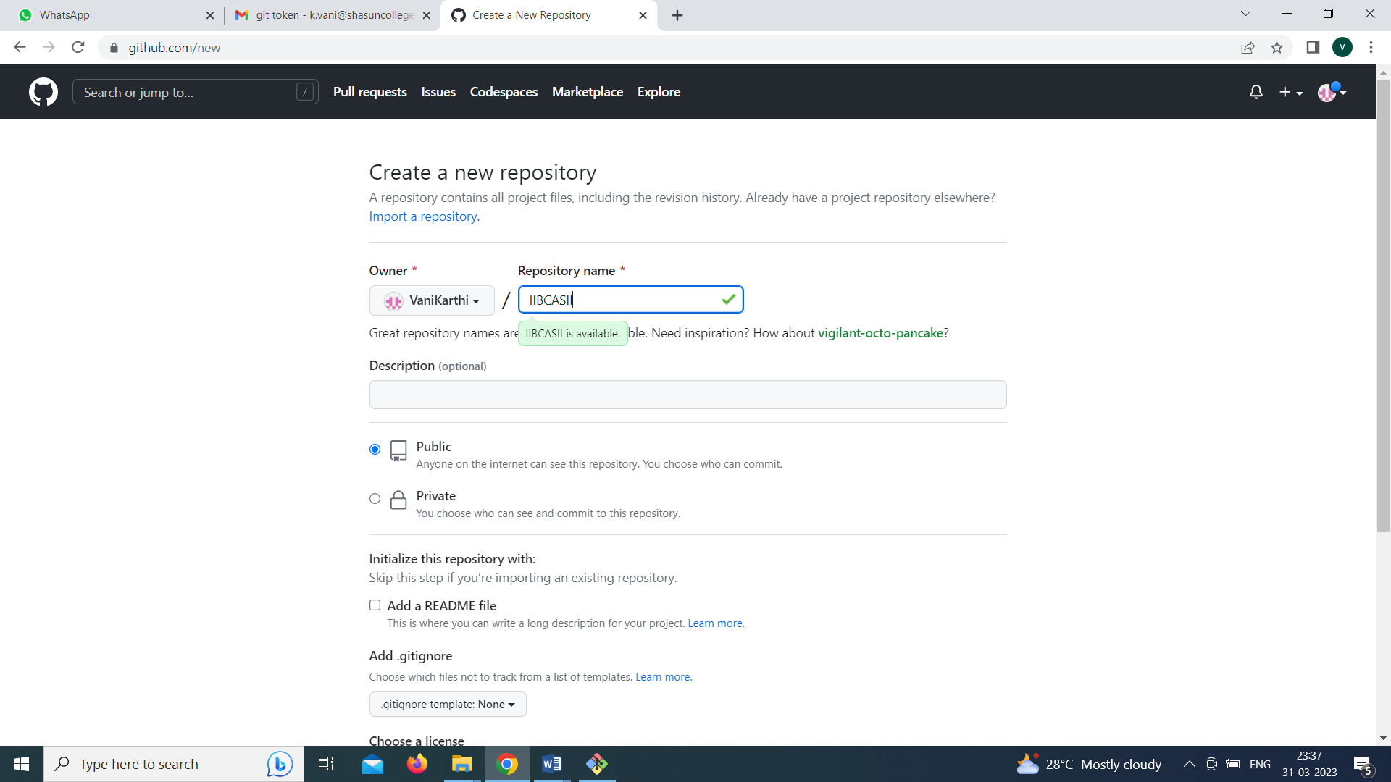

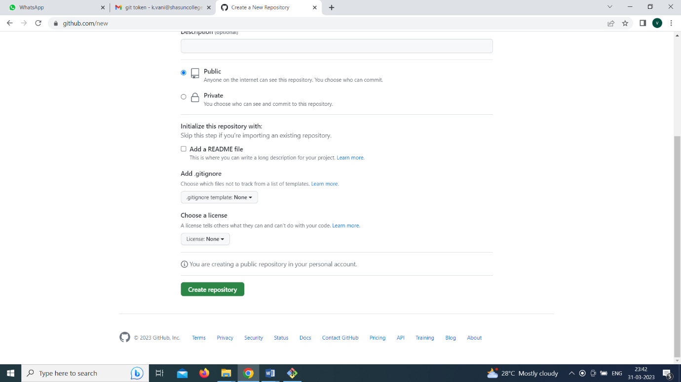

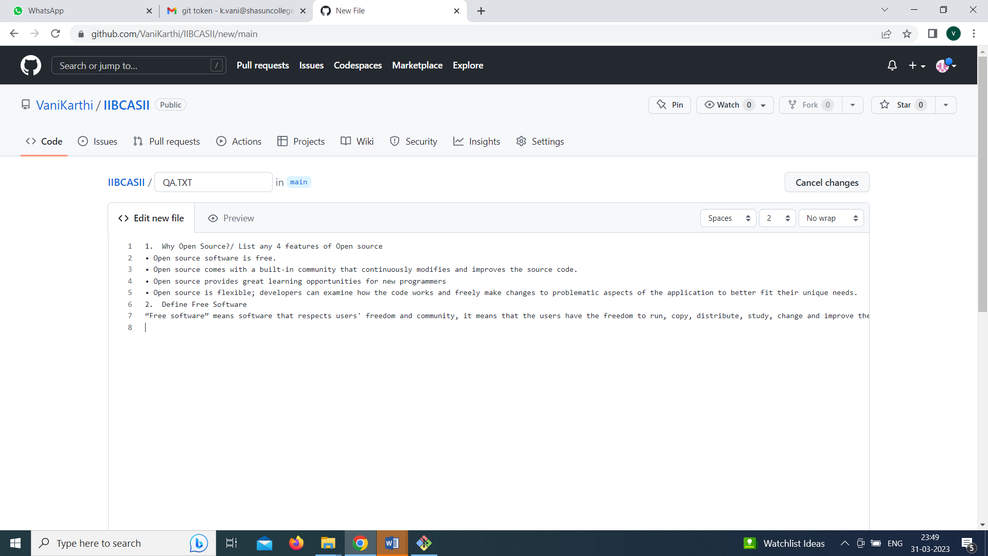

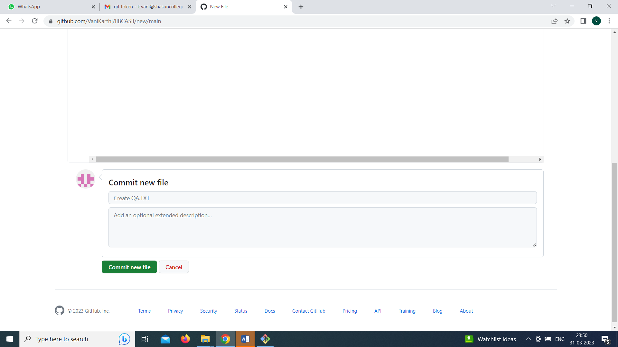

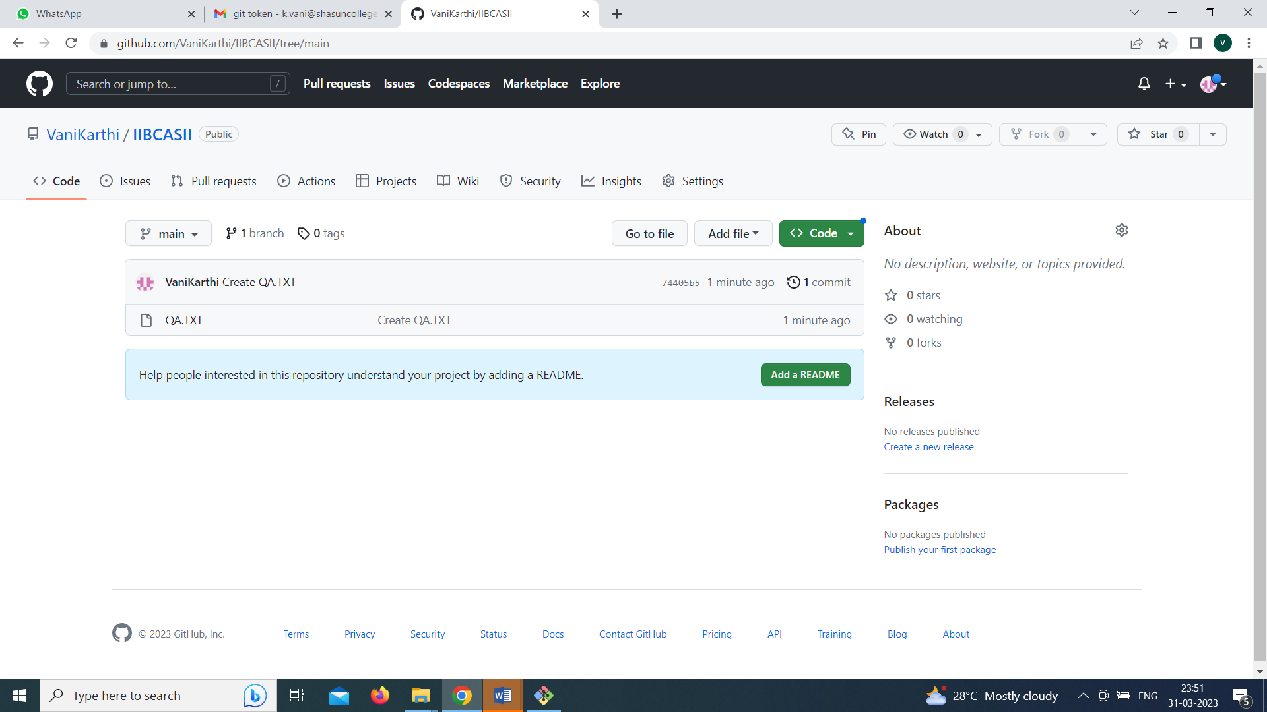

**4. Create a GIT control system to access the old code**

**Aim:**

To Create a GIT control system to access the old code

**Steps:**

1. Open the GitHub repository
2. Open git bash
3. Git clone <https://github.com/VaniKarthi/IIBCASII.git>
4. cd IIBCASII
5. ls –l

**Output**

